Credit Score Classification Using Machine Learning

Comparative Analysis of Random Forest and XGBoost Models
Name: Shijan shiby
Project Assigned On: 29 January 2026
Tools Used: Python, Scikit-Learn, XGBoost, Matplotlib, Seaborn, Power BI
Project Type: Machine Learning Classification Project

1. Introduction
Credit risk assessment is a critical component of financial decision-making in banking and lending institutions. Traditionally, credit evaluation involves manual analysis of financial records and credit history, which can be time-consuming and prone to inconsistency.
This project aims to develop a machine learning model to classify customers into three credit score categories:
- Poor
- Standard
- Good
The objective is to automate credit risk classification using financial and behavioral data, thereby improving decision speed, consistency, and risk management.

2. Problem Statement
Manual credit evaluation presents several challenges:
- Inconsistent assessment criteria
- Time-intensive approval processes
- Increased risk of loan default
- Difficulty in scaling operations
The goal of this project is to build a predictive model that accurately classifies customer credit scores based on multiple financial attributes.

3. Dataset Description
The dataset contains over 90,000 customer records with financial and credit-related attributes.
Target Variable:
Credit Score
- 0 → Poor
- 1 → Standard
- 2 → Good
Key Features:
- Annual Income
- Outstanding Debt
- Credit_Utilization_Ratio
- Credit Mix
- Interest_Rate
- Delay_from_due_date
- Total_EMI_per_month
- Credit_History_Age
- Num_of_Loan
The dataset includes demographic, financial, and credit behavior information used to determine creditworthiness.

4. Data Preprocessing
Data preprocessing is a critical step before model training.
Steps Performed:
1. Data Cleaning
- Removed irrelevant columns (ID, SSN, etc.)
- Corrected inconsistent numeric formats
2. Handling Missing Values
- Numerical features → Filled using median
- Categorical features → Filled using mode
3. Encoding
Categorical variables were converted into numeric format using:
- Label Encoding
4. Train-Test Split
- 80% Training Data
- 20% Testing Data
- Stratified sampling applied to maintain class balance

PAGE 6
5. Exploratory Data Analysis (EDA)
EDA was performed to understand feature distributions and relationships.
Key Observations:
- Customers with high Outstanding Debt tend to have Poor credit scores.
- Higher Interest Rates are associated with lower credit ratings.
- Customers with stable income and low EMI ratios are mostly classified as Good.
- Class distribution shows majority in good category.
(Insert screenshots here:)
- Credit Score Distribution Chart
- Correlation Heatmap
- Income Distribution Graph

6. Feature Engineering
To improve predictive performance, additional financial indicators were created.
Engineered Features:
- Debt-to-Income Ratio
- EMI-to-Income Ratio
- Credit History converted to numeric months
These financial ratios help represent customer financial stress more effectively than raw values alone.

7. Model Development
Two classification models were implemented and compared:
1. Random Forest Classifier
- n_estimators = 200–400
- max_depth tuned
- random_state = 42
Random Forest is an ensemble model that builds multiple decision trees and aggregates results to improve stability and reduce overfitting.
2. XGBoost Classifier
- learning_rate tuned
- max_depth optimized
- n_estimators adjusted
XGBoost is a gradient boosting algorithm known for high performance in structured datasets.

8. Model Evaluation & Comparison
Models were evaluated using:
- Accuracy
- Precision
- Recall
- F1-Score
- Confusion Matrix
Performance Comparison:
Model | Accuracy
Random Forest | 78%
XGBoost | 76.8%
Random Forest outperformed XGBoost and showed better class balance, especially for the Good category.
Therefore, Random Forest was selected as the final model.

9. Confusion Matrix Analysis
The confusion matrix provides detailed insight into classification performance.
Key Findings:
- Strong performance in predicting Good credit class.
- Some misclassification between Poor and Standard categories.
- Balanced recall across all classes.
The diagonal values represent correct predictions, while off-diagonal values indicate misclassification.
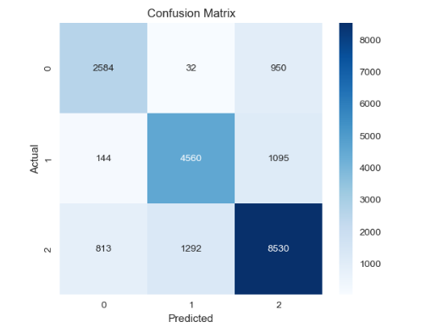

10. Feature Importance Analysis
Feature importance was extracted from the Random Forest model.
Top Influential Features:
- Outstanding Debt
- Interest_Rate
- Credit Mix
- Delay_from_due_date
- Credit_Utilization_Ratio
- Annual Income
- Total_EMI_per_month
Outstanding Debt emerged as the most influential predictor of credit score classification.
This confirms that debt burden and repayment behavior strongly affect credit risk.
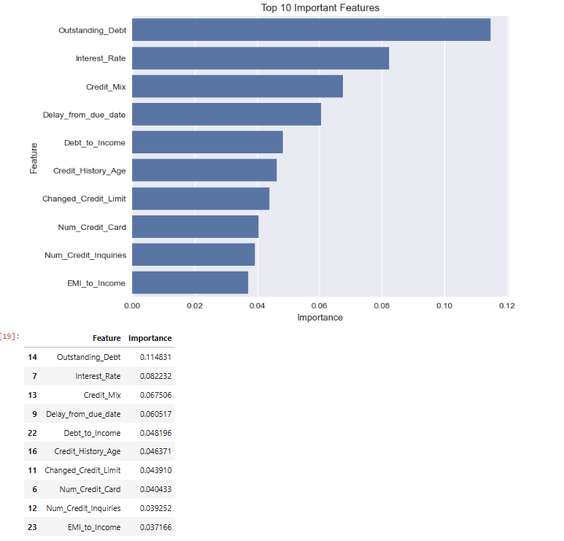

11. Business Impact
The developed model provides significant business benefits:
- Automates credit score classification
- Reduces manual processing time
- Improves consistency in risk assessment
- Supports faster loan approval decisions
- Reduces potential loan default risk
The integration of Power BI dashboard enables interactive exploration of model results and financial insights.

12. Conclusion
The Random Forest model achieved 78% accuracy in multi-class credit score classification.
The model demonstrates:
- Stable predictive performance
- Balanced classification across categories
- Strong ability to identify high-risk customers
This project successfully implements an end-to-end machine learning pipeline, including data preprocessing, model comparison, evaluation, and visualization.

13. Future Improvements
Future enhancements may include:
- Advanced hyperparameter tuning
- SHAP explainability analysis
- Real-time deployment using web frameworks
- Integration with live banking systems
- Larger real-world dataset testing

